NORMALIZATION

Normalization : Technique to organize data into multiple related tables , to minimize data redundancy.

* **Benefit of normalization**
* Elimination of data redundancy : normalization reduce data redundancy by breaking down data in to smaller , logical units redundant data can lead to inconsistencies and anomalies, such as update anomalies
* Improved data integrity : normalization helps enforce data integrity by preventing inconsistent or contradictory data from being stored in the database by organizing relationships between them
* Increased efficiency and performance : normalization reduces the amount of duplicate data stored in the database resulting in smaller table sizes and improved query performance
* **Problems with the database without normalization**
* **Insert** : Redundant data occurs when the same information is repeated in multiple places within the database this redundancy wastes storage space and increases the likelihood of inconsistencies and data anomalies

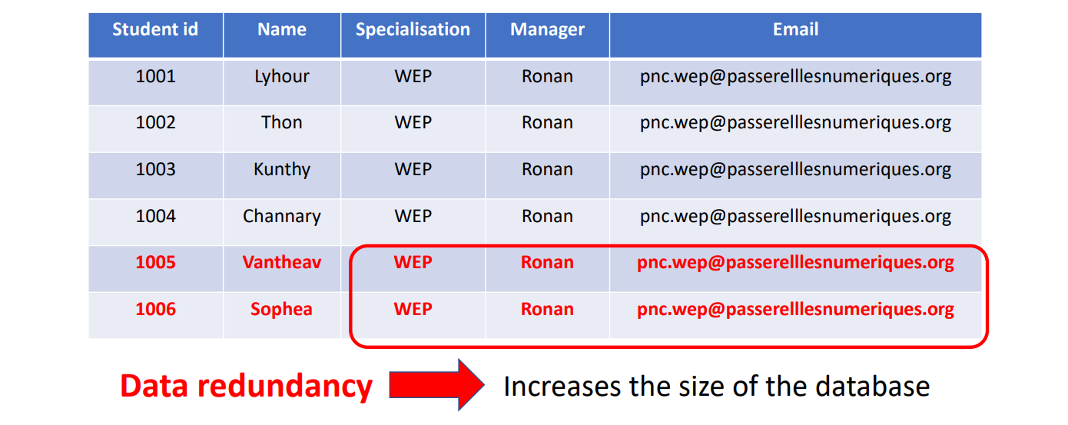

* **Update** : Update anomalies occur when modifying data leads to inconsistencies

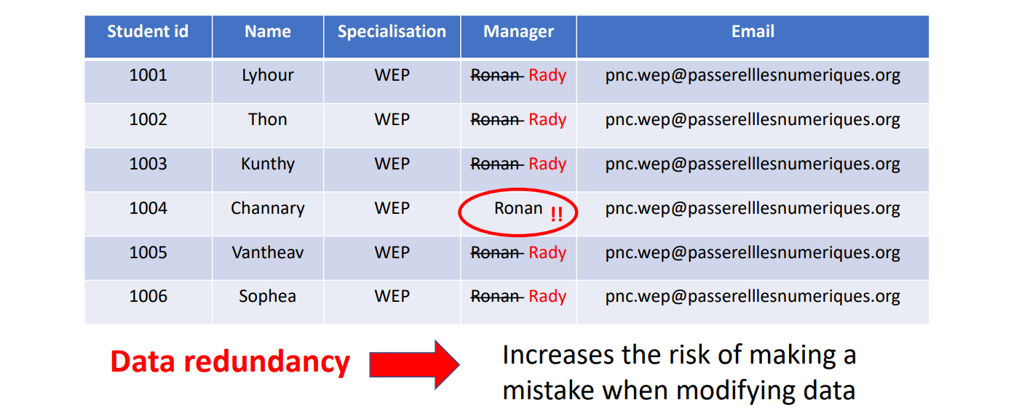

* 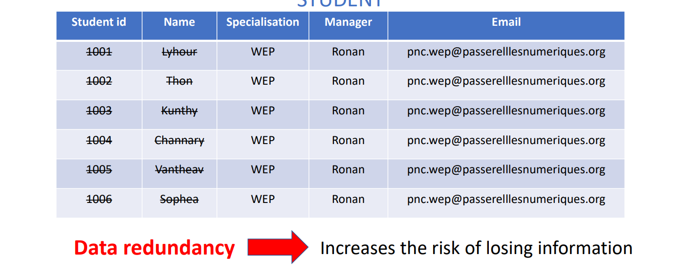**Delete** : Deletion anomalies occur when removing data unintentionally removes other related data that should be preserved
* **Normalization forms**
* **First form normalization** 
  + All column must be have single values
  + All column must be have only one data type
  + Each column must be have unique
  + The order in which you store the data doesn’t matter



* **Second normalization form**
  + Make sure already following first normal form
  + All nun key attribute must be related to all primary key

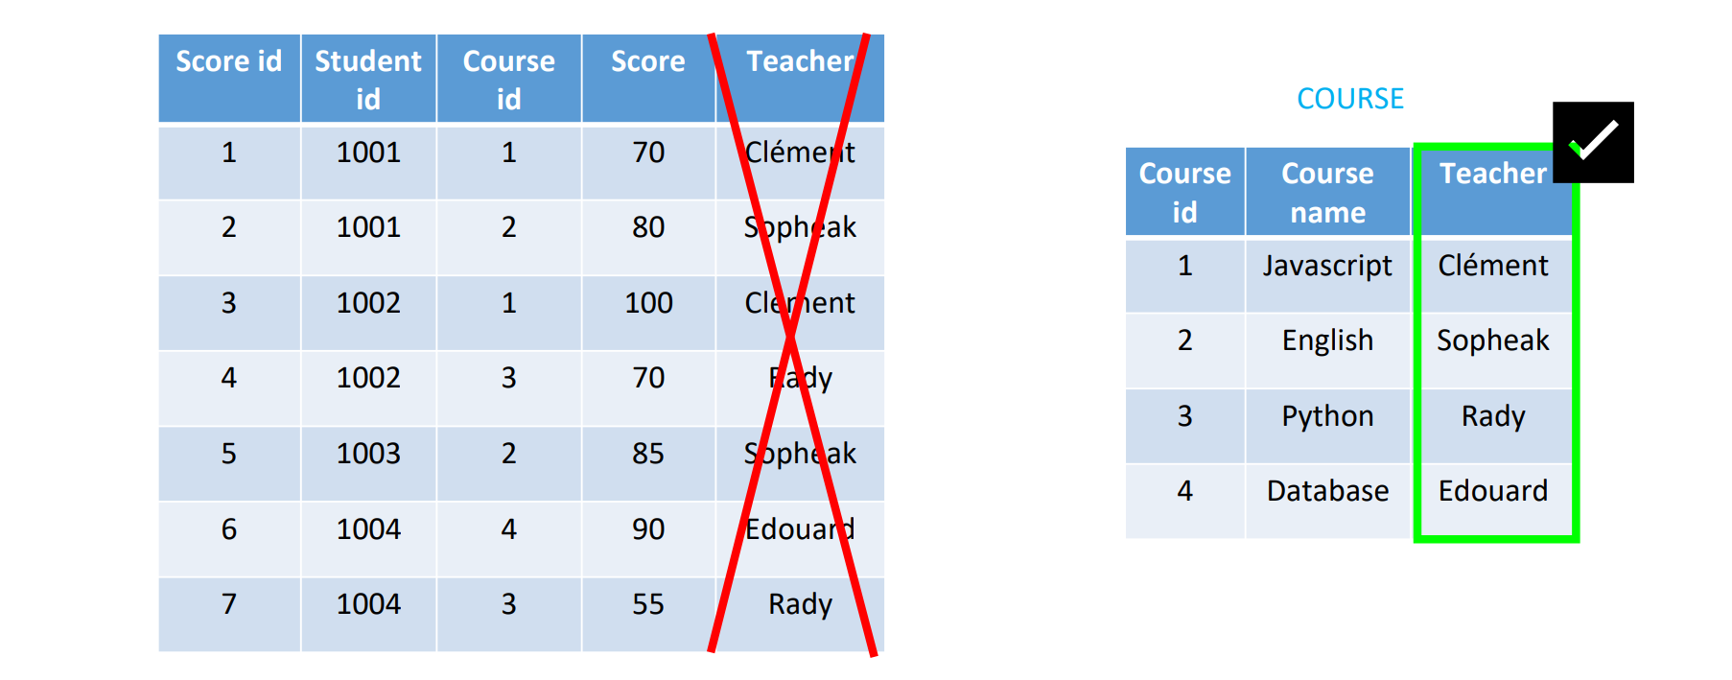

* **Third normalization form**
  + Make sure already following second normal form
  + For all key attribute hasn’t transitive dependency

